Use-Case Specifications

Version 1.1

Table of Contents
1. Use-Case Model 3
1.1. Introduction 3
1.2. General Actors Descriptions 3
1.3. Use-Case Model 3
2. Use Cases 4
2.1. Use Case: Select Movie 4
2.2 Use Case: Pay Movie 4
2.3 Use Case: Cancel a Movie 5
3 Class Diagram(s) 5

Use-Case Specifications

Use-Case Model

Introduction
Customers can display the movies according to time, rate and pay the movies via their credit or debit card through GVC Movie Ticket Purchase system.

General Actors Descriptions
Customer
Any persons interacting with the terminal to purchase a ticket or seek help.
Administrator
A person managing a movie information such as title, time, day, price and rate policy
Movie Database
Files contain the data about movies, tickets and payment information
Payment System
Validate inputted card number and perform payment progress then return the result

Use-Case Model
[GVC Movie Ticket System]
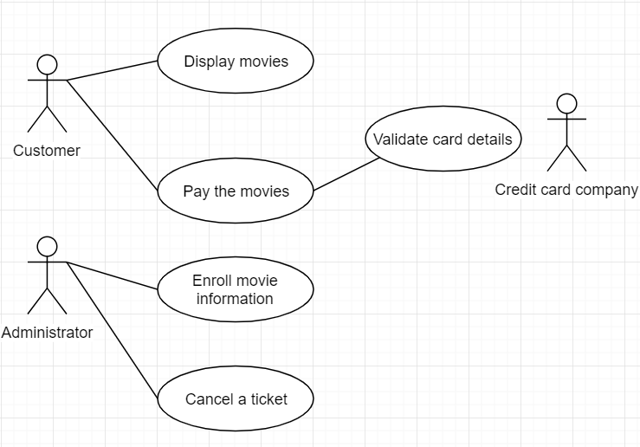

Use Cases

Use Case: Select Movie
Use Case Name: | Select Movie | Use Case ID: | UC001
Primary Actor: | Customer
Description: | The customer can check movies through some conditions
Triggering Event: | The customer selects conditions such as day, time and date.
Steps Performed (Main Path)
1. Select the search condition with date and rate
2. Display the movies according to the conditions
Extensions or Alternate Scenarios
1a. The customer chooses the date condition
1b. The customer chooses the rate condition
Pre-Conditions: | A Customer chooses at least one condition
Post-Conditions: | All results meet the search condition will be shown
Assumptions: | The movies will be shown regardless of the available seats, error message will occur when a customer try to pay it
Success Guarantee: | - The results will be shown only based on date & time and rate conditions
Outstanding Issues: | A customer chooses past time
Priority: | HIGH

Use Case: Pay Movie
Use Case Name: | Pay Movie | Use Case ID: | UC002
Primary Actor: | Customer, Credit Company
Description: | The customer pays selected movies and gets the result from the credit company
Triggering Event: | The customer already selected movies with proper age and available seats, then click the payment button
Steps Performed (Main Path)
1. Select the movies
2. Input the age
3. Choose payment method
4. Input card number
5. Print the receipt
Extensions or Alternate Scenarios
3a. Choose credit card payment
3b. Choose debit card payment
Pre-Conditions: | A customer chooses at least one movie
Post-Conditions: | A customer can check the details paid
Assumptions: | The result from the credit card company is always “completed”
Success Guarantee: | - A customer can print the receipt
Outstanding Issues: | A customer inputs wrong card number with non-numeric values
Priority: | HIGH

Use Case: Cancel a Movie
Use Case Name: | Cancel a Movie | Use Case ID: | UC003
Primary Actor: | Administrator, manager
Description: | The staff cancels the ticket when a customer request
Triggering Event: | A customer requests the cancellation
Steps Performed (Main Path)
1. A staff accepts the request cancellation from a customer
2. Input the ticket number
3. Change the status of ticket to be cancelled
Extensions or Alternate Scenarios
2a. Multi ticket numbers could be inputted at a time
Pre-Conditions: | A customer requests a valid ticket for cancellation
Post-Conditions: | A valid ticket cancelled successfully
Assumptions: | The ticket is valid status
Success Guarantee: | - A valid ticket number should be modified to cancel status
Outstanding Issues: | A customer forgot the ticket number and don’t have the receipt
Priority: | HIGH

Class Diagram(s)

